

**CP301**

**Developmental Engineering Project**

Topic:

Heat Loss Minimization

Under the guidance of -

Dr. Navneeth & Dr. Devranjan Samanta  
Assistant Professor, Department of Mechanical Engineering  
IIT Ropar

Submitted by

Atharv Srivastava 2022MEB1301

Atharva Sharma 2022MEB1302

Darius Johanana 2022MEB130

Mohit Sharma 2022MEB1326

**Acknowledgement**

We extend our heartfelt gratitude to **Dr. Navaneeth and Dr. Devranjan Samanta**, our project guide, for there unwavering support and invaluable guidance, which have been instrumental in the success of our development project.

Furthermore, we sincerely appreciate our **parents** for their constant encouragement, enabling us to explore and learn beyond our horizons. We also acknowledge the contributions of numerous **researchers and scholars** whose work has inspired and informed our project, significantly shaping our ideas and approach.

A special thanks to our **fellow mechanical batchmates** for their support, collaboration, and assistance in various aspects of our project. Lastly, we express our gratitude to everyone who has contributed to our project's growth and progress.

With the **grace of the Almighty**, we have thoroughly enjoyed working on this endeavour as a team and look forward to continued learning and development in the future.

**Index**

1. Title
2. Aim
3. Motivation
4. Introduction
5. Background and Literature Review
6. Experimental/Analytical Details
7. Result
8. Discussion
9. Future Work
10. Conclusion
11. Reference

**Title of the Project:**

Heating and Cooling Load Calculation

**Aim:**

The objective of this project is to calculate the heating and cooling load for a single room using the weather data of Chandigarh. The aim is to minimize this load by implementing various modifications, such as:

* Applying different wall coatings to enhance thermal insulation.
* Using advanced ventilation systems for improved air circulation.
* Optimizing insulation properties to reduce heat loss/gain.

**Motivation:**

The primary motivation behind this study is to develop energy-efficient solutions for slum areas where the use of air conditioners and heaters is not feasible due to economic and infrastructural constraints. By optimizing building materials and insulation techniques, we aim to provide affordable and sustainable alternatives to maintain comfortable indoor temperatures without relying on energy-intensive appliances. This initiative can significantly improve the living conditions of underprivileged communities while promoting energy conservation.

**Introduction:**

Heating and cooling load calculations play a vital role in determining the amount of energy required to maintain comfortable indoor temperatures. These calculations consider various factors, such as external weather conditions, building materials, insulation levels, and occupancy patterns. A well-optimized heating and cooling system not only ensures indoor comfort but also contributes to reducing energy consumption, making it a crucial aspect of sustainable building design.

Buildings, especially in extreme climates, rely heavily on heating, ventilation, and air conditioning (HVAC) systems to maintain an optimal indoor environment. However, high energy demand from HVAC systems leads to increased operational costs and environmental concerns. By implementing energy-efficient materials and optimizing room insulation, we can significantly reduce the energy load required for heating and cooling. This study aims to analyze different building materials and their thermal properties to identify the most effective strategies for minimizing heat transfer and improving energy efficiency.

**Background and Literature Review:**

Building energy efficiency is a critical factor in modern sustainable construction. Numerous studies highlight the impact of insulation materials, HVAC system design, and ventilation strategies on heating and cooling loads. Based on insights from computational investigations into energy consumption in buildings, bio-inspired materials and composite walls have emerged as promising solutions for improving thermal performance.

* **Use of Bio-Inspired Materials:** Studies have shown that materials such as rice husk, hempcrete, and sugarcane bagasse can significantly reduce heat transfer through walls, minimizing cooling and heating loads. These materials have lower thermal conductivity and higher insulation properties compared to conventional bricks.
* **Composite Walls for Energy Reduction:** Research on multi-layered walls combining different materials has demonstrated superior thermal insulation, reducing the overall energy consumption of buildings.
* **Impact of Sustainable Wall Materials:** Investigations into bio-based construction materials indicate that incorporating renewable and locally available resources can enhance energy efficiency and lower construction costs while maintaining structural integrity.

By leveraging such findings, this study aims to explore effective wall compositions and insulation strategies that can be implemented in slum areas to reduce energy dependency on HVAC systems.

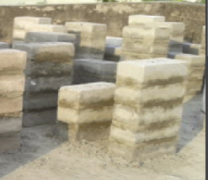

Fig.1 Sugarcane Bagasse Ash(SBA) Brick

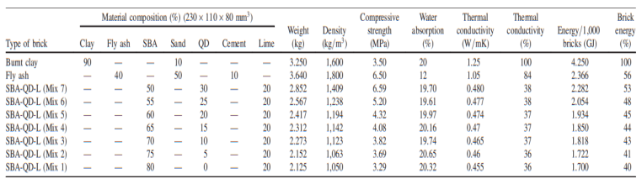

Table1 Properties of SBA Bricks

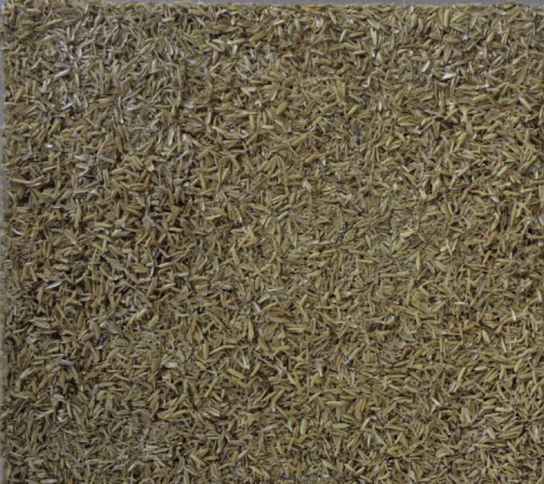

Fig. 2 Rice husk expanded cork



Table 2 Properties of Rice expandable cork

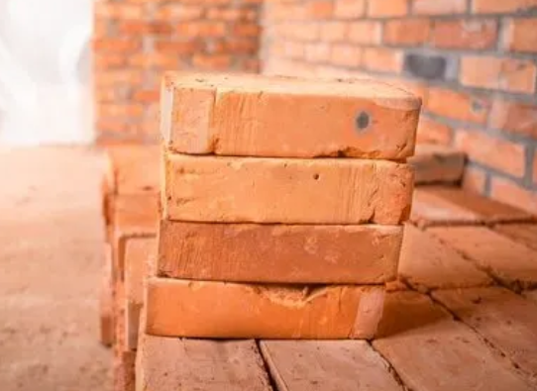

Fig. 3 Clay Brick

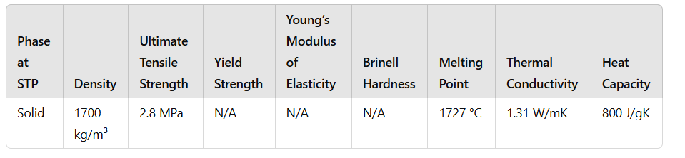

Table 3 Properties of clay brick

**Objective:**

The main objectives of this study include:

* Defining the room geometry, including walls and windows.
* Selecting appropriate materials and simulating their impact on energy efficiency.
* Calculating heating and cooling loads using EnergyPlus software.
* Evaluating different building materials and coatings to identify the most effective combination.
* Proposing modifications to minimize energy consumption.

The study involves the following technical aspects:

* **Weather Data:** Chandigarh’s and Shimla’s climatic conditions are used for accurate load calculations.
* **Simulation Tool:** EnergyPlus software is employed to evaluate heating and cooling loads.
* **Material Selection:** Different wall compositions are tested:
  + File 1: Single-layer brick wall.,
  + File 2: Rice husk expanded cork,
  + File 3: Sugarcane Bagasse Ash (SBA) Brick.
* **HVAC System:** <Specs of the HVAC system to be inputted>

**Experimental/Analytical Details:**

The methodology followed in this study includes:

1. **Room Definition:** A single room model with four walls, one window, and an HVAC system.
2. **Material Selection:** Various wall compositions are tested to assess their impact on thermal insulation.
3. **Simulation Setup:** EnergyPlus is used to simulate heating and cooling loads for different scenarios.
4. **Load Calculation:** The impact of various wall materials is noted.
5. **Result Interpretation:** Comparison of different materials to determine the most energy-efficient configuration.

Room Geometry defined on EnergyPlus:

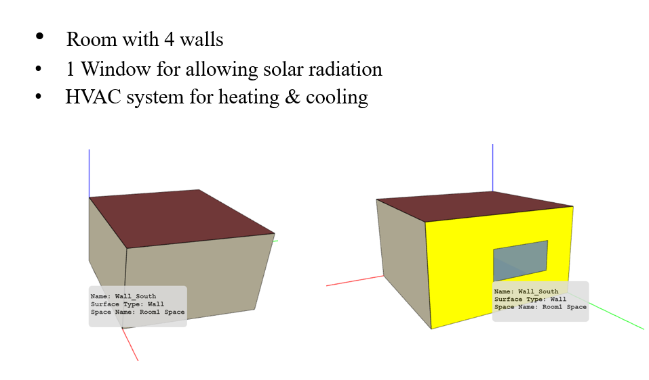

**Results and Discussion:**

For Chandigarh:

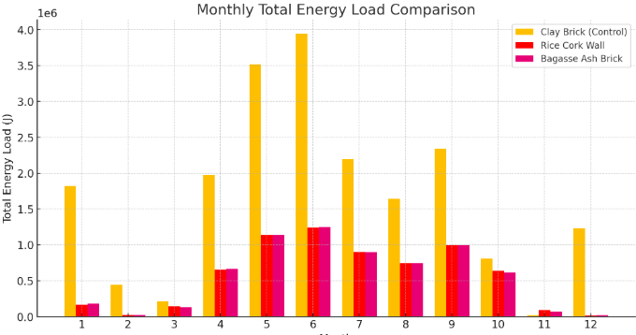

**Plot 1** Graph between Total Energy load with Months

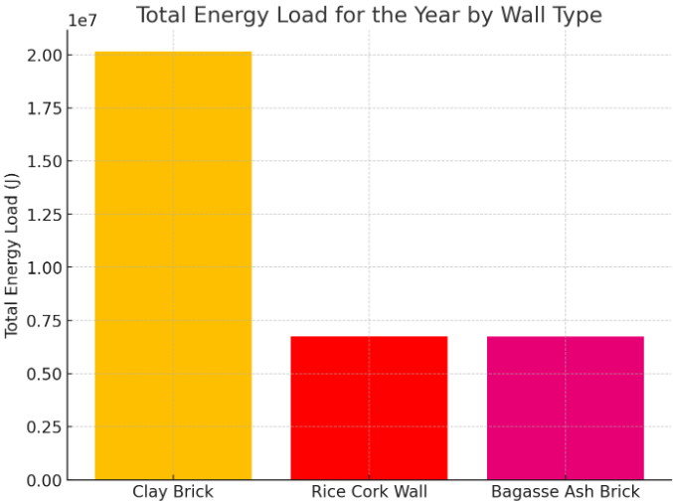

**Plot 2** Graph of Total Energy load of various walls

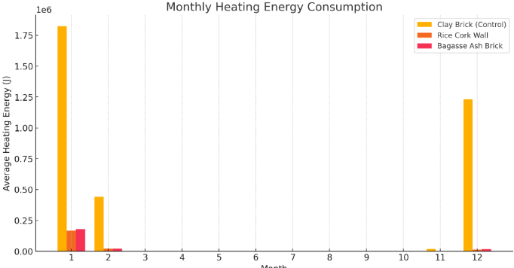

**Plot 3** Graph between Heating load with Months

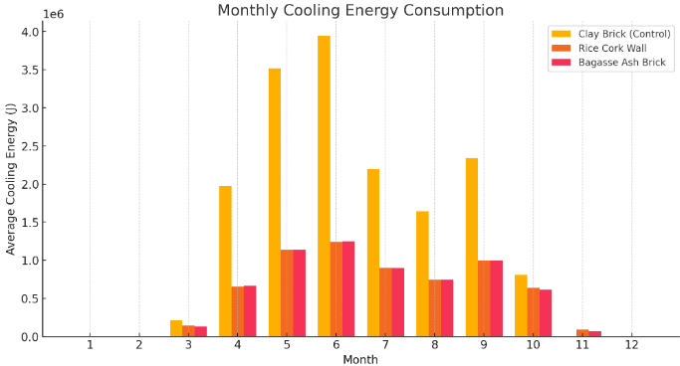

**Plot 4** Graph between Cooling load with Months

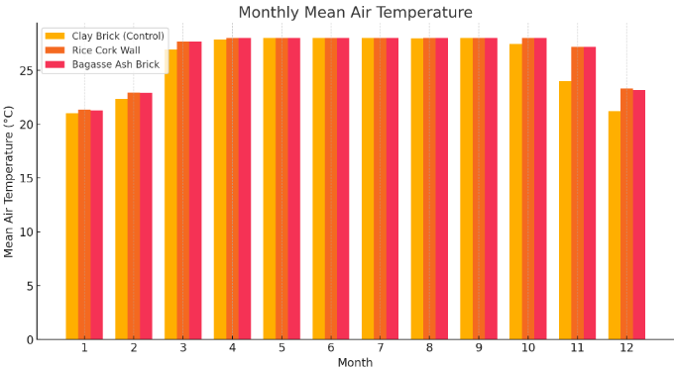

**Plot 5** Graph between Mean air Temperature with Months

The simulation results highlight the differences in heating and cooling loads based on material selection. Key observations include:

* **Basic Brick Wall:** Exhibited higher energy demand due to poor insulation.
* **Composite Wall:** Reduced heat transfer, leading to lower energy consumption.
* **Optimized Material:** Provided the best thermal performance, significantly minimizing heating and cooling requirements.

**Conclusion:** The study demonstrates that material selection plays a crucial role in heating and cooling efficiency. Using optimized composite walls with enhanced insulation properties can substantially reduce energy consumption. The findings support the need for integrating sustainable building materials in modern construction.

**Further Work to be Done:**

* Redesign the HVAC system to improve efficiency.
* Explore additional insulation materials for enhanced thermal resistance.
* Investigate the impact of room geometry modifications on energy performance.
* Extend the study to larger buildings for broader applicability.